DESCRIPTIVE REPORT

Problem Statement:
Youtube advertisers pay content creators based on adviews and clicks for the goods and services being marketed. They want to estimate the adview based on other metrics like comments, likes etc. The problem statement is therefore to train various regression models and choose the best one to predict the number of adviews. The data needs to be refined and cleaned before feeding in the algorithms for better results.

Objective:

To build a machine learning regression to predict youtube adview count based on other youtube metrics.

Source of Data Set:
The following data set is taken from the Github repository of an International (Py) expert because of which the data set is well defined and easily understandable (i.e features are well defined making us to make our project more efficient).

1.Data Description
The file train.csv contains metrics and other details of about 13000 youtube videos.The training data contains (13000 rows and 9 columns) as seen form (train_df.shape):
The metrics include number of views, likes, dislikes, comments and apart from that published date, duration and category are also included. The train.csv file also contains the metric number of adviews which is our target variable for prediction.

Load DataSet:
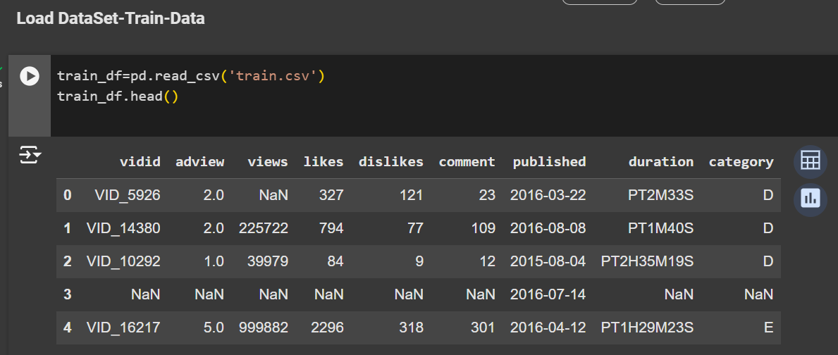
Data Shape:
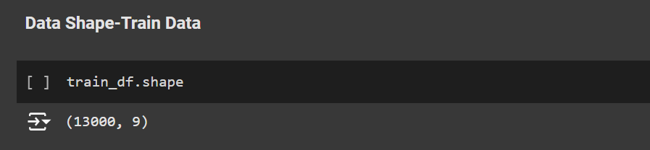

Data Type:
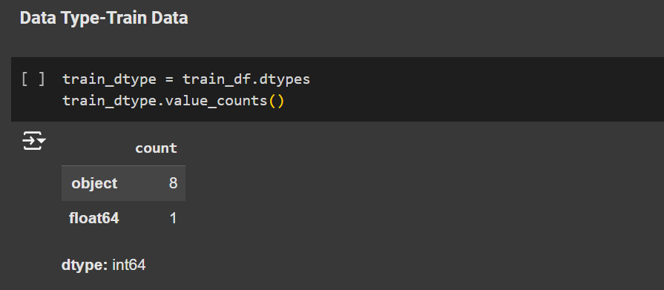
Data Info:
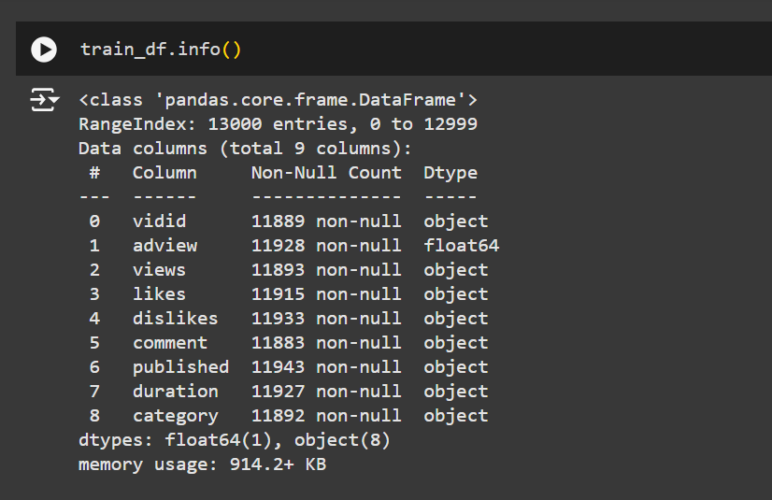
Null-Values:
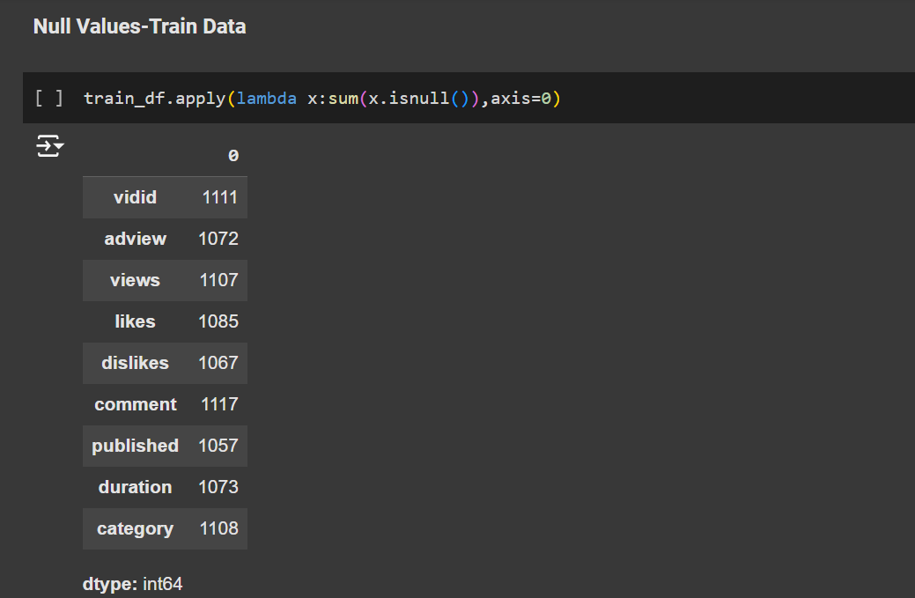

2.Data Cleaning
- First of all we identified missing values in the dataset and handled by using e.g,by various functions as train_df.isnull(),
- Secondly, convert the ‘duration’ column from Youtube’s format(‘PT1H2M3S’) to seconds using a function checki(x).
- Removed duplicate rows from the dataset using train_df.drop_duplicates(),train_df.dropna().

Transformation:
- Extracts the year from the 'published' column and creates a new column called 'year'. This allows you to analyze data based on the year the videos were published.
- Make sure the 'views' column is treated as numbers. This is important for calculations and statistical analysis.
Normalization:
The code normalizes the columns 'adview', 'views', 'likes', 'dislikes', and 'comment' in your dataset.
Normalization is a technique to scale data to a specific range, in this case, between 0 and 1. This is often done to improve the performance of machine learning algorithms.
The code also visualizes the data before and after normalization using box plots to show the effect of the scaling.
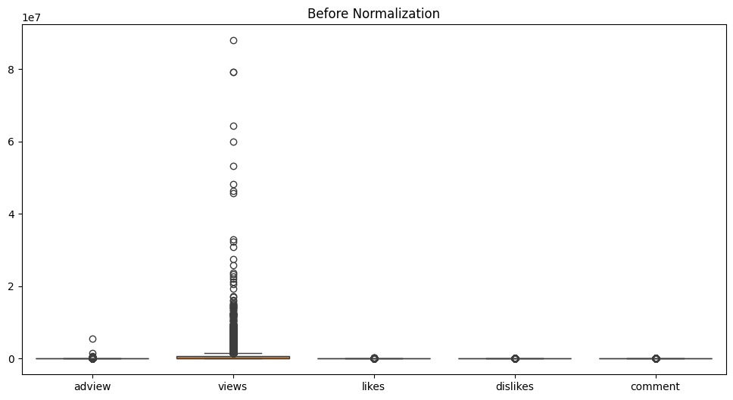
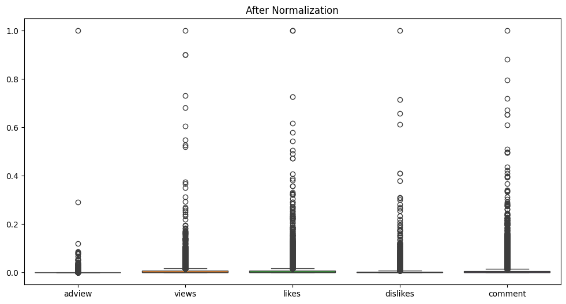
Size of Box (Before Normalization):
- The position and size of the boxes indicate the spread and central tendency of these features in their original units. You'll likely see boxes with different sizes and positions, reflecting the different ranges and distributions of these features.
Size of Box(After Normalization):
- The box for each column now represents the IQR of the normalized data.
- The boxes will generally be narrower and positioned within the range of 0 to 1, reflecting the effect of Min-Max scaling.
- The relative positions of the quartiles within each box should be similar to the before-normalization plot, but they are now in a scaled 0-1 range.
3.Exploratory Data Analysis(EDA):
Visualizing Null-Values:
Before Data Cleaning:
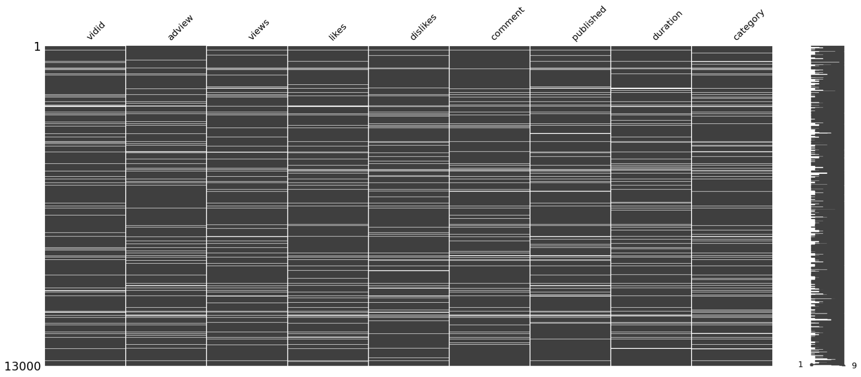
After Data Cleaning:
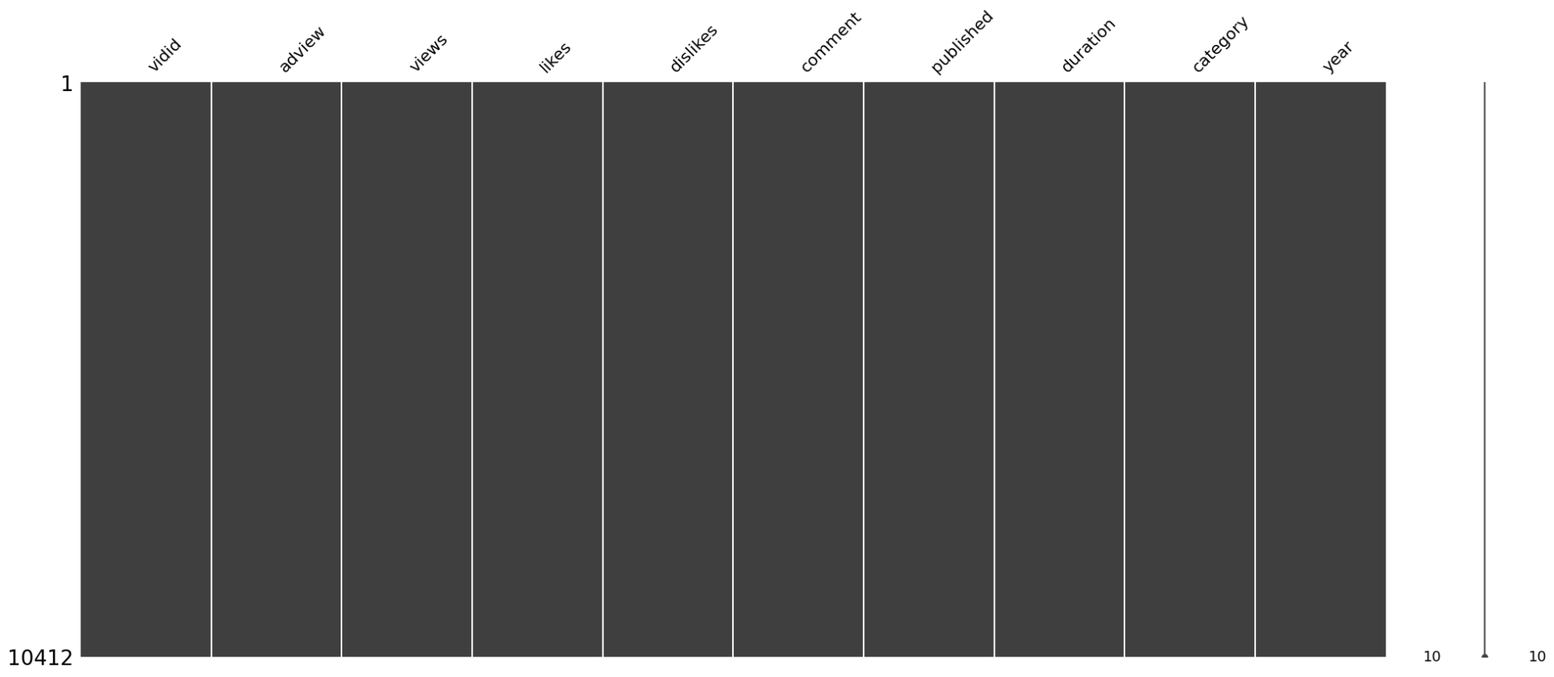
Univariate Analysis:
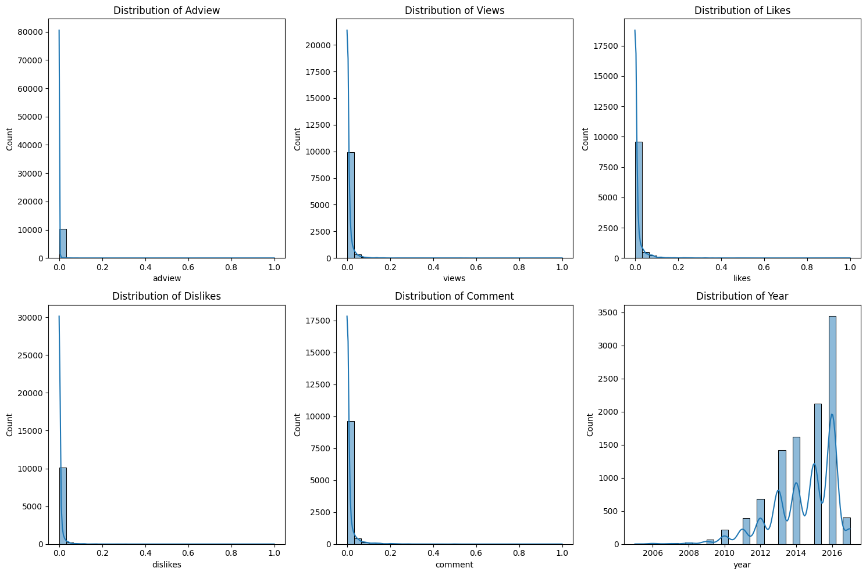
Summary:
- Adview: The histogram likely shows a right-skewed distribution, meaning most videos have lower adviews, and a few have extremely high adviews. This indicates the presence of outliers that might need to be addressed in further analysis.
- Views: Similar to adview, views probably exhibit a right-skewed distribution with a long tail, signifying that most videos have a relatively lower number of views compared to a few exceptionally popular videos.
- Likes: This histogram probably also shows a right-skewed distribution, suggesting that most videos receive a moderate number of likes, while some videos gather a very large number of likes.
- Dislikes: This distribution might be slightly less skewed than likes and views, but still with a longer tail on the right, indicating a tendency for videos to have fewer dislikes overall.
- Comment: The comment distribution is likely heavily skewed to the right, revealing that most videos receive a small number of comments, while a few videos generate extensive discussions.
- Year: This histogram would display the frequency of videos published in different years. You can observe the distribution across years, identify potential trends, and see if there are any significant gaps or clusters in the data.
Overall Observations:
- The histograms collectively reveal a general pattern of right-skewness in the distribution of most features. This is common in data related to online content, where a minority of items (videos, articles, etc.) achieve significantly higher engagement than the majority.
- Outliers might be present in features like adview, views, likes, and comments, which could affect further analysis and model training. Consider investigating these outliers and potentially applying transformations or removing them if appropriate.
- The distribution of publication years could provide insights into data collection periods and potential temporal trends.

Bivariate Analysis:
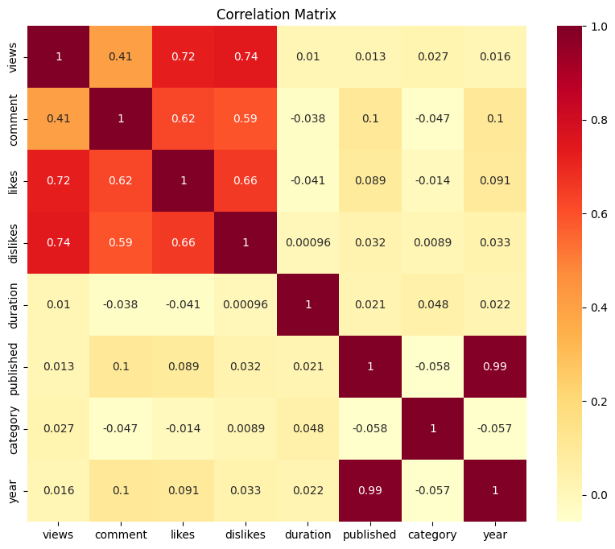
- Strong Positive Correlations:
  - Views, Likes, Dislikes, Comments: These features likely show strong positive correlations with each other, indicating that videos with more views tend to have more likes, dislikes, and comments. This suggests a general trend of higher engagement across these metrics.
- Moderate Positive Correlations:
  - Adview and Views: There's likely a moderate positive correlation between adview and views, suggesting that videos with higher views tend to generate more ad revenue. This is expected as ad revenue often depends on viewership.
  - Adview and Likes: You might also see a moderate positive correlation between adview and likes, implying that videos with more likes tend to have higher adviews. This could be because popular videos attract more viewers and thus more ad impressions.
  - Adview and Comments: A moderate positive correlation might also exist between adview and comments, suggesting that videos with more comments may have higher adviews. This could be due to increased user engagement and interaction, leading to more ad exposure.
- Weak or No Correlations:
  - Duration and Other Features: Duration might have weak or no significant correlations with other features like views, likes, dislikes, or comments. This suggests that the length of a video doesn't necessarily determine its popularity or engagement level.
  - Category and Other Features: The encoded 'category' feature might have weak or inconsistent correlations with other features, depending on the specific categories and their relationship to engagement metrics. Further investigation into category-specific trends might be needed.
  - Year and Other Features: Publication year ('year') might show weak or no correlations with most features, except possibly views if there's a trend of increasing or decreasing viewership over time.
Overall Insights:
- Engagement Metrics: Views, likes, dislikes, and comments tend to move together, indicating a general trend of higher engagement for videos with more views and interaction.
- Adview Influence: Adview appears to be positively correlated with views, likes, and comments, suggesting that higher engagement metrics contribute to higher ad revenue.
- Limited Impact of Duration and Category: Duration and category seem to have less direct influence on engagement or adview compared to other features.
- Potential Year-Based Trends: You might need to explore the correlation between publication year and other features more closely to identify any temporal patterns or changes in engagement.

Project Part 2
- Transformation
- Dimensionality Reduction
- Machine Learning Models
- Machine Learning Evaluation
- Prediction(conclusion)
Transformation:
For transformation we need to do the Normalization of our data:
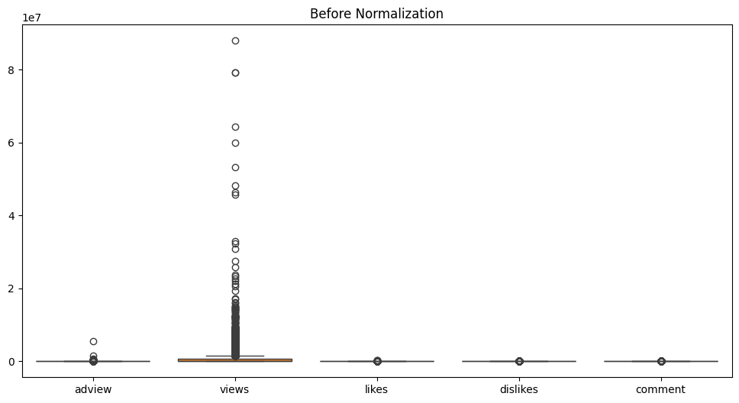

Key Observations:
- Views:
  - This metric has a significant range, with many outliers present. The presence of these outliers suggests a few instances of extremely high view counts, which can skew the overall analysis.
- Ad Views:
  - Similar to views, ad views also display some outliers but are less pronounced than in the views metric. This indicates a relatively more consistent distribution.
- Likes and Comments:
  - Both metrics show a tighter distribution with fewer outliers, suggesting that user engagement (likes and comments) is more stable across the dataset.
- Dislikes:
  - The dislikes metric shows minimal variation, clustering at the lower end, indicating that negative feedback is relatively rare.

Implications:
- Normalization Need: Due to the extreme values in the views and ad views, normalization or transformation (like log transformation) may be necessary to make the data more manageable and to improve the effectiveness of any further analysis or modeling.
- Focus on Outliers: It may be beneficial to investigate the outliers in the views metric further to understand what drives these high counts and whether they are anomalies or indicative of a particular trend.
After Normalization:
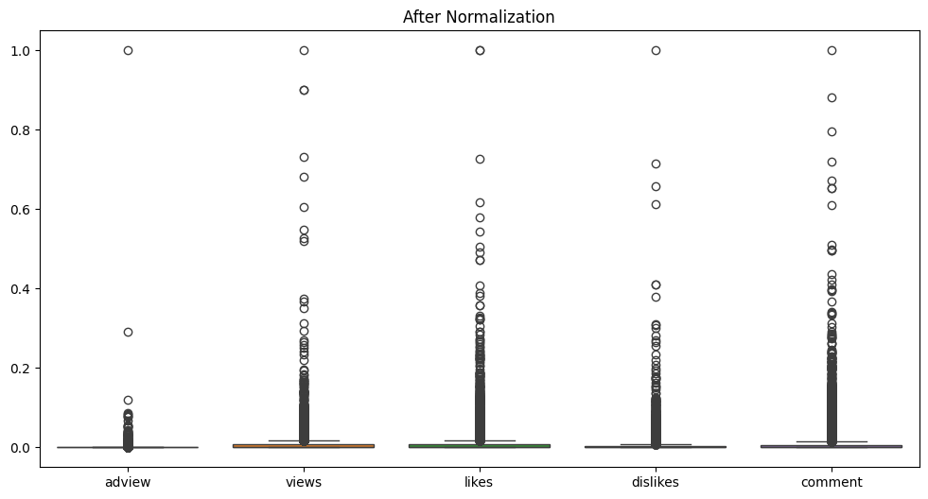
Result:
- Improved Comparability: The normalization makes it easier to compare the distributions across different metrics, facilitating better insights into user engagement.
- Further Analysis: With the extreme values tempered, statistical analyses or machine learning models can potentially yield more reliable results.
Dimensionality Reduction:
For the dimensionality Reduction we will implement feature Selection:
There are three categorical features. These are “category”, “vivid”, “published”.
- “vivid” is the id of video.So it has no impact on target variable.
- “published” column has been transformed to another year column so we don’t need a published column.
- Also “category” has no effect on target variable.
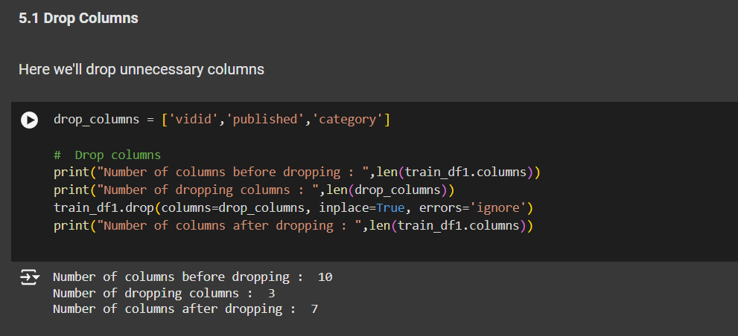

Machine Learning Models:
Linear Regression Purpose: Linear Regression is used to model the relationship between a dependent variable (in our case, "adview") and one or more independent variables (features like "views," "likes," "dislikes," etc.) by fitting a linear equation to the observed data.
Why it's used here: In our code, we are trying to predict the "adview" based on other features. Linear Regression is a good starting point because it's a simple and widely used model for regression tasks. It can provide a baseline performance and insights into the linear relationships between the features and the target variable.
Assumptions: Linear Regression assumes that there is a linear relationship between the features and the target variable, the data is normally distributed, and there is little or no multicollinearity (high correlation between independent variables).
Support Vector Regressor (SVR)
Purpose: SVR is also used for regression tasks, but it uses a different approach. It tries to find a hyperplane that best fits the data while staying within a certain margin of error. It can handle non-linear relationships using kernel functions.
Why it's used here: SVR is often used when there is a complex relationship between the features and the target variable that might not be captured well by a linear model. It's also robust to outliers and can handle high-dimensional data.
Advantages: SVR can be more flexible than Linear Regression and can handle non-linear relationships. It's also less sensitive to outliers and can perform well with high-dimensional data.
We are using both Linear Regression and SVR to compare their performance on our dataset. This allows us to see which model performs better in terms of prediction accuracy. Linear Regression serves as a simple baseline, while SVR is a more complex model that might capture non-linear relationships in the data.
Evaluation:
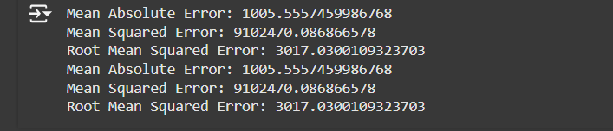
Comparison: Both models exhibit identical performance across all three evaluation metrics (MAE, MSE, and RMSE). This suggests that the models might be fitting the data similarly or that one model might be redundant in this scenario.
Interpretation:
MAE: On average, both models' predictions are off by approximately 1005.56 units from the actual values.
MSE: The average squared difference between the predicted and actual values is 9102470.09 for both models. MSE is sensitive to outliers due to the squaring operation.
RMSE: The square root of MSE, providing a more interpretable measure of error in the same units as the target variable. In this case, the RMSE is 3017.03 for both models, indicating the typical prediction error.

Decision Tree Regressor
Purpose: Decision Trees are used for both classification and regression tasks. In your case, you're using a Decision Tree Regressor to predict a continuous target variable ("adview"). It works by recursively partitioning the data based on features to create a tree-like structure that maps features to predicted values.
Why it's used here: Decision Trees are relatively easy to understand and interpret. They can capture nonlinear relationships between features and the target variable, which might be present in your YouTube ad view data. They can also handle both categorical and numerical features without requiring extensive data preprocessing.
Advantages: Interpretability, handling non-linearity, handling mixed data types.
Disadvantages: Prone to overfitting (memorizing the training data), instability (small changes in data can lead to different trees).
Random Forest Regressor
Purpose: Random Forest is an ensemble learning method that combines multiple Decision Trees to make more accurate and robust predictions. It works by building a collection of Decision Trees, each trained on a random subset of the data and features. The final prediction is an average (or other aggregation) of the predictions from individual trees.
Why it's used here: Random Forests address the overfitting issue of individual Decision Trees by introducing randomness and averaging predictions. This leads to better generalization performance on unseen data. They are often more accurate and stable than single Decision Trees.
Advantages: Improved accuracy, robustness, reduced overfitting, handling high dimensionality.
Disadvantages: Can be computationally expensive, less interpretable than single Decision Trees.
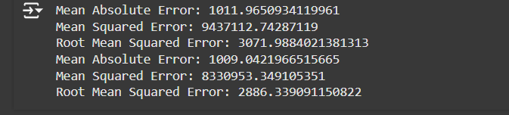
In our code: We're using both Decision Tree and Random Forest to predict "adview" and compare their performance using evaluation metrics (MAE, MSE, RMSE). The Decision Tree serves as a baseline model, showcasing the performance of a single tree-based approach. The Random Forest is used to improve upon the Decision Tree by leveraging the power of ensemble learning, aiming for better prediction accuracy and generalization.
Comparison:
MAE: The Random Forest Regressor has a slightly lower MAE (1009.04) compared to the Decision Tree Regressor (1011.97), indicating that, on average, its predictions are closer to the actual values.
MSE: The Random Forest Regressor also has a lower MSE (8330953.35) compared to the Decision Tree Regressor (9437112.74), suggesting that it has less overall prediction error.
RMSE: Similarly, the Random Forest Regressor has a lower RMSE (2886.34) compared to the Decision Tree Regressor (3071.99), further reinforcing its better performance.
Interpretation: The Random Forest Regressor generally outperforms the Decision Tree Regressor in this scenario based on all three evaluation metrics.
The lower MAE, MSE, and RMSE values for the Random Forest Regressor indicate that it is better at capturing the underlying patterns in the data and making more accurate predictions.
This improvement is likely due to the ensemble nature of Random Forest, where multiple decision trees are combined to reduce overfitting and improve prediction accuracy.

Artificial Neural Networks:
Why an ANN is Used
Complex Relationships: ANNs are capable of learning complex, non-linear relationships between features and the target variable, which can be beneficial for predicting YouTube ad views as the underlying factors might be intricate.
Flexibility: ANNs can adapt to different data patterns and distributions, making them suitable for a variety of datasets.
Feature Learning: ANNs can automatically learn relevant features from the data, reducing the need for extensive manual feature engineering.
In our code: We're using an ANN as another model to predict "adview" and compare its performance with the Decision Tree, Random Forest, Linear Regression, and SVR models. This allows us to assess the effectiveness of a neural network-based approach for your specific task.
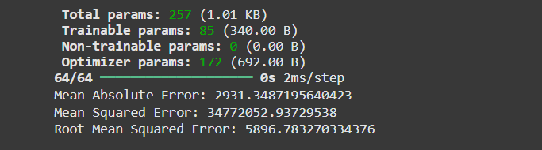
Total params: The total number of parameters (weights and biases) in your model is 257. These parameters are the values that the model learns during training to make predictions.
Trainable params: 85 of these parameters are trainable, meaning they will be updated during the training process to minimize the loss function.
Non-trainable params: Currently, there are no non-trainable parameters in your model. Non-trainable parameters are usually used for pre-trained layers or fixed components.
Optimizer params: The optimizer (Adam in our case) has 172 parameters of its own, which are used to control the learning process.
Mean Absolute Error (MAE): 2931.34 - This means that, on average, our model's predictions are off by about 2931 units from the actual ad view values.
Mean Squared Error (MSE): 34772052.93729538 - This is a measure of the average squared difference between predicted and actual values. It's more sensitive to large errors.
Root Mean Squared Error (RMSE): 5896.78 - The square root of MSE, providing a more interpretable metric in the same units as the target variable (ad views).
Overall Interpretation
The relatively high MAE and RMSE values suggest that the ANN model might not be capturing the underlying patterns in the data effectively or that there might be significant noise or variability in the target variable. Compared to our previous models (Linear Regression, Support Vector Regressor, Decision Tree, Random Forest), the ANN seems to be performing worse based on these metrics.

Final Prediction:


